Exhibit 3.2: High-Fidelity Mockups

# Landing Page

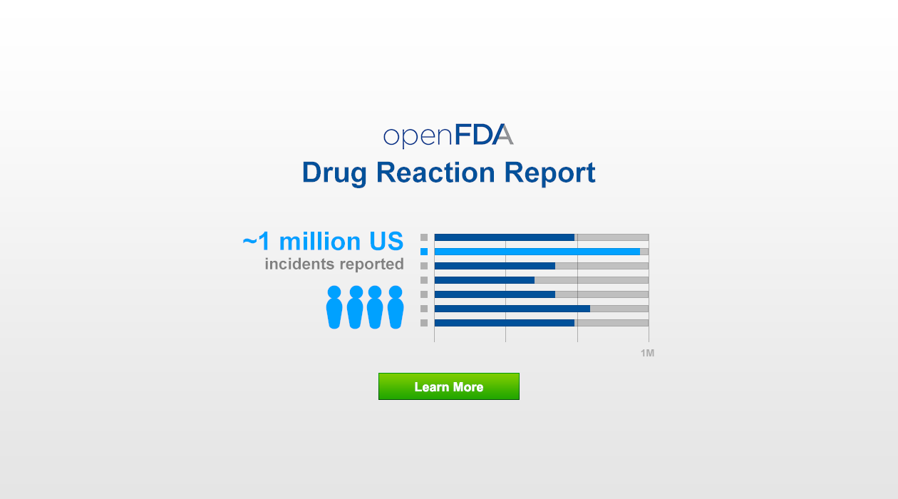

# Search & Results Page

# C:\Users\kphan\Desktop\18F\18f-proposal--page-mocks__v--1.png